## **Self-Reflection: Ask a question Kaggle com**

1.

Question 1



One of the most helpful resources for learning R is the large community of fellow data analysts. R programmers all over the world assist one another on online forums to discuss and solve syntax questions and data problems.

In this self-reflection, you’ll get familiar with asking your peers for help with R. Specifically, you’ll go to [Kaggle.com](https://www.kaggle.com/), which you may remember from when you learned about data types and structures in Course 3.

Once you’re there, write a post on the forum asking a question about R. Whether it’s a question about learning strategies or R syntax, someone on Kaggle should be able to help. Remember to use the search function to check if your question has already been answered--you save time for everyone when you avoid duplicate questions.

### Writing a post on Kaggle



To write a post on the Kaggle.com forum, follow these steps.

Step 1: Log into your Kaggle account by clicking Sign In in the top-right corner.

Step 2: Navigate to the Communities tab on the left-hand menu. Then select the Beginner subcategory. Then, click the New Topic button to create a new thread on the forum.

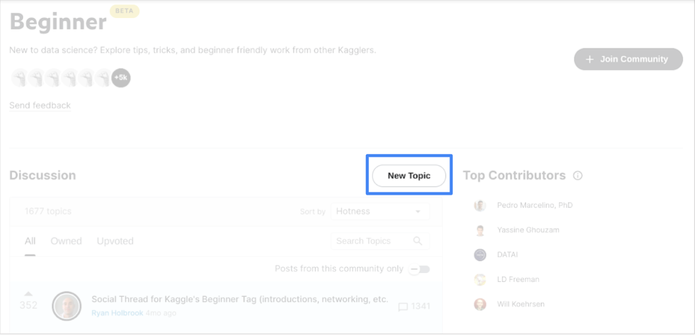

Step 3: Write the Topic Title and content of your question, then click Publish Topic.

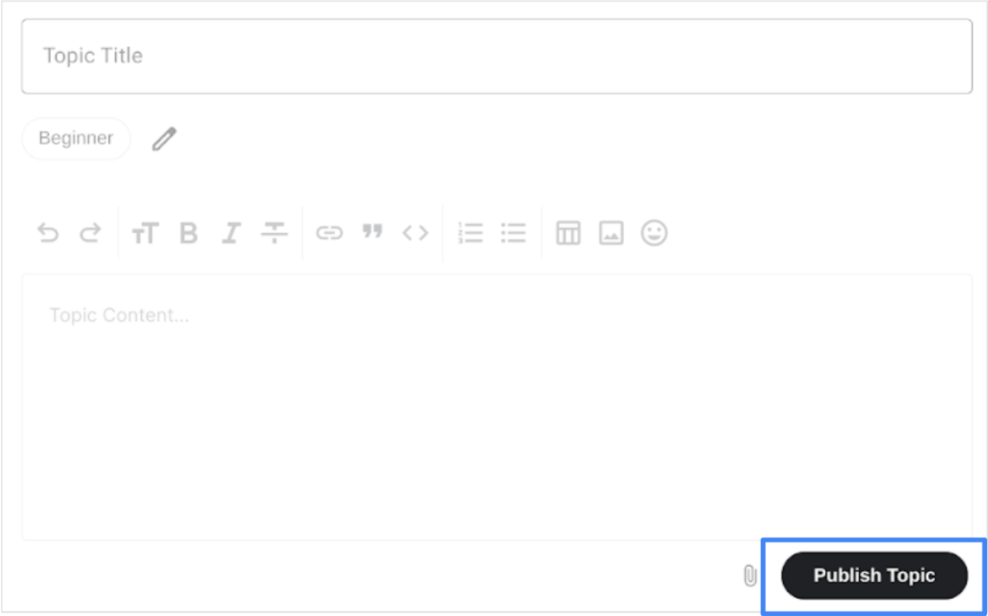

You’ve successfully posted a question to the Kaggle forum. Kaggle and other data analytics forums can be invaluable resources as you continue to learn about R and any other data analytics topics.

## Reflection



Once you’re finished, wait some time for a peer to respond to your question. When they do, reflect on your experience.

* What did you learn?
* How responsive were they?
* How else would you like to use Kaggle to support you as you learn R?